Project Report

For

DAILY WATER INTAKE TRACKER
Date: 04-05-2026
Prepared by:
Program with Batch | SAP ID | Name
B.Tech CS - 63 | 590027907 | Samarth Mendiratta

School Of Computer Science
UPES, DEHRADUN- 248007. Uttarakhand

Table of Contents
Topic |  | Page No
Table of Content
1 | Introduction
 | 1.1 Purpose of the Project
 | 1.2 Target Beneficiary
 | 1.3 Project Scope
2 | Project Description
 | 2.1 Reference Algorithm
 | 2.2 Data Analysis and Visualization Tools
 | 2.3 Project Features
 | 2.4 User Classes and Characteristics
 | 2.5 Design and Implementation Constraints
 | 2.6 Design diagrams
3 | System Requirements
 | 3.1 User Interface
 | 3.2 Software Interface
 | 3.3 Database Interface
 | 3.4 Protocols
4

INTRODUCTION
Purpose of the project:

Managing hydration is a key part of daily health, but it is easy to forget to drink water throughout a busy day. This Daily Water Tracker helps users log their intake in real-time. Instead of looking at broad weekly trends, this system focuses on the current 24-hour cycle, helping users visualize exactly when they are drinking water and if they are falling behind during specific hours of the day.
Target Beneficiary:

- Students – to manage hydration during long academic hours.
- Office Workers – to ensure they drink water during long sitting hours.
- Salaried Individuals – to track health habits during work shifts.
- Patients – to monitor fluid intake as per medical requirements.
Project Scope:

The scope of this project is to develop a simple application for managing real-time daily water intake. It allows users to record intake amounts which are automatically timestamped. The system stores data in a database for easy retrieval and provides a graphical representation of consumption patterns throughout the day.

PROJECT DESCRIPTION

Reference Algorithm:

- Start the application and connect to the MongoDB database.
- Display the graphical user interface.
- Take user input for water amount in ml.
- Automatically attach the current date and hour to the record.
- Store valid data in the database.
- Query the database for the current date only.
- Group data by hour using Pandas.
- Show graphical representation of hourly intake using Matplotlib.
- Exit the application.
Data Analysis and visualization tools:

- Pandas – Used to organize and group intake data by hour.
- NumPy – Used for numerical calculations like total daily intake.
- Matplotlib – Used to create hourly bar charts for visualization.
Project Features:

- Easy-to-use graphical user interface built with Tkinter.
- Automatic timestamping and hourly grouping.
- Litre-based conversion for the final analytics display.
- Real-time graph refreshing after each entry.
- "Clear Today" feature to reset current daily logs.
User Classes and Characteristics:

- Students – Use the system to maintain focus and health during study sessions.
- Salaried Employees – Use it to monitor and improve daily spending and health habits.
- General Users – Individuals who want to replace manual logs with a digital system.
Design Implementation and Constraint:

The project is implemented using Python with Tkinter for the GUI and MongoDB for database storage. Analysis is done using Pandas, NumPy, and Matplotlib. The system is limited to local use, depends on MongoDB running locally on port 27017, and focuses specifically on the current 24-hour window.
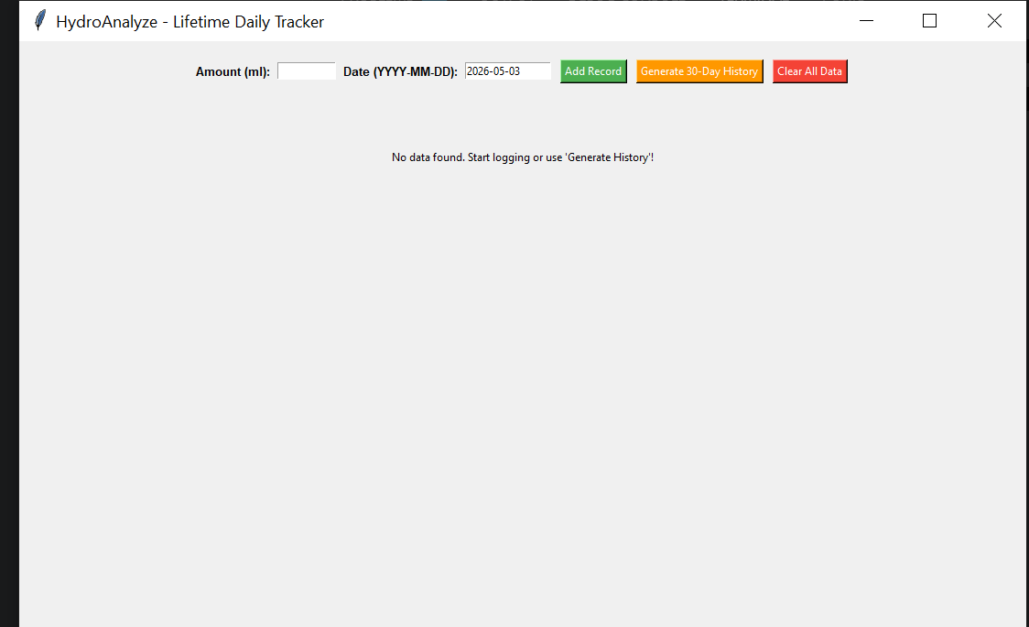
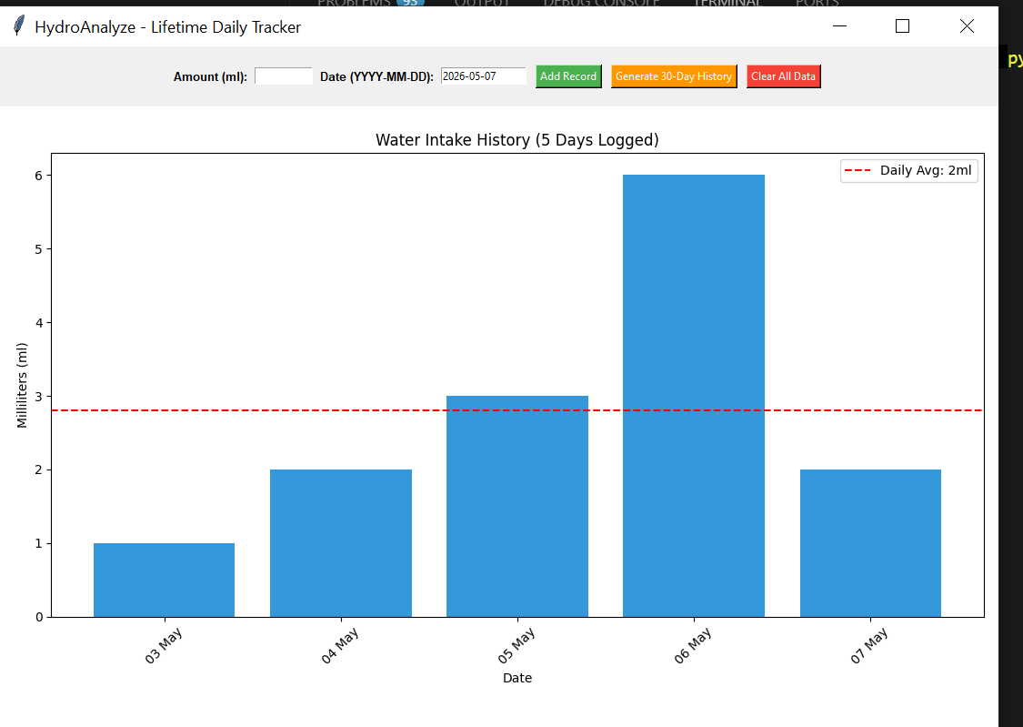

SYSTEM REQUIREMENTS

User Interface:

The application provides a simple graphical interface using Tkinter. It is designed to be clean and interactive, allowing users to log intake with minimal effort.

Software Interface:

The system uses Python for logic and user interaction. It integrates Pandas, NumPy, and Matplotlib to provide a smooth connection between data input and graphical output.
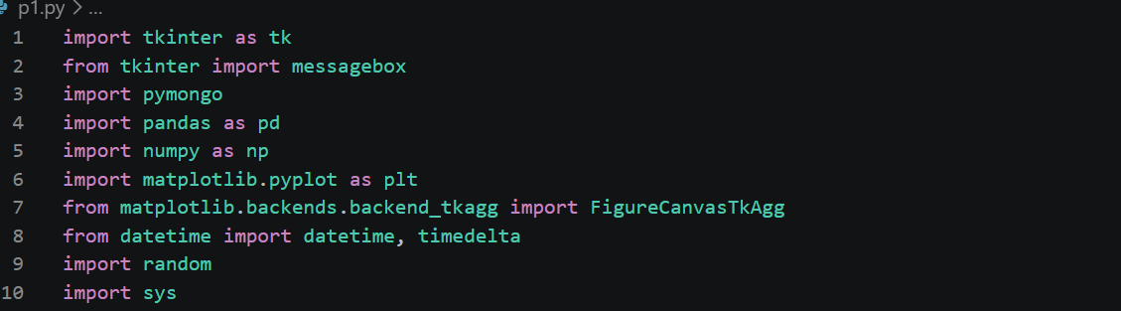

Database Interface:

- Uses MongoDB to store all intake records as documents.
- Connects to the database using the PyMongo library.
- Performs filtered queries based on the current system date.

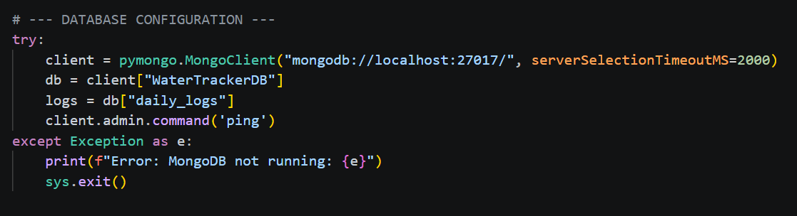
Protocols:

- Uses MongoDB communication over TCP/IP for database operations.
- Uses Python internal libraries for data processing and GUI interaction.
- Connects to local MongoDB server via localhost (127.0.0.1).
GITHUB LINK:

https://github.com/Sam247-coder/python-project/blob/main/python%20project%20water%20intake%20tracker

